You can use or adapt the model language in this template to draft a resolution by your AAUP chapter for establishing clear limits to OPM contracts. Replace highlighted text in brackets with language appropriate for your institution and chapter. Substitute the logo in the header above with your own chapter logo.

Resolution before the [AAUP chapter, department, institution, or senate]
[date]

Whereas faculty at [the AAUP chapter, department, school, or senate] witness how online programs are being developed at more and more colleges and universities across the country to increase access to higher education but without a strong emphasis on quality;

Whereas these online programs are often born out of contracts with for-profit, third-party online program management companies, also known as OPMs;

Whereas many OPM contracts involve the institution in purchasing costly bundled services instead of individual services purchased one at a time based on specific needs;

Whereas institutions are increasingly entering into contracts with OPMs that are unnecessarily long and difficult to exit;

Whereas many contracts require burdensome revenue sharing agreements in which anywhere from 35% to 80% of student tuition from the online program is collected by the for-profit OPM instead of reinvested in the institution, faculty, students, and staff;

Whereas contracts often involve aggressive marketing to students and place control over recruiting, admissions, enrollment decisions and student data in the hands of a for-profit company, not the higher education institution;

Whereas contracts often delegate decision making about the core academic functions of the program to OPM staff instead of faculty;

Whereas this trend is unsustainable for a higher education system that sees education as a public good, not a commodity; now, therefore, be it

Resolved, that faculty [of the AAUP chapter, department, school, or senate] reject all current and future proposals for [degree programs] managed under the [OPM] that involve:
  - bundling services;
  - requiring long-term contracts that are costly to exit;
  - tuition-sharing agreements;
  - aggressive marketing and student recruitment practices;
  - OPM control over admissions, enrollment decisions, and student data; or
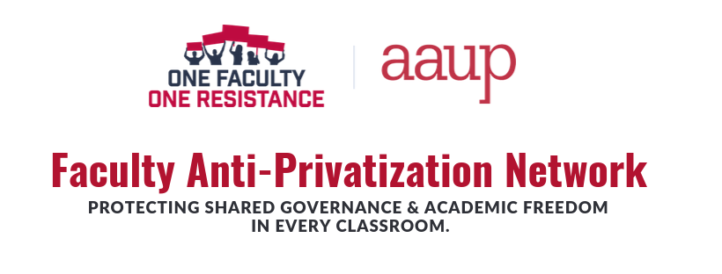
  - decisions about core academic functions not made by faculty.

